**Chat Application**

**Submitted to:**

Submitted to the Department of Computer Science and Engineering Bangabandhu Sheikh Mujibur Rahman Science and Technology University in partial fulfillment to the requirements for the degree of B.Sc. Engineering.



Department of Computer Science & Engineering

BSMRSTU, Gopalganj

**Date:**

**Verified by: Submitted by:**

Md. Martuza Ahamad Mokadderul Islam

Assistant Professor, Department of CSE, BSMRSTU 18CSE075

I

**Abstract :**

The chat application with Java socket programming project aims to develop a real-time chat application that enables communication between multiple clients over a network. The project utilizes socket programming concepts in Java to establish client-server communication and facilitate message exchange.

The system architecture consists of two main components: the server and the client. The server acts as a central hub, accepting client connections and managing the communication between them. Each client connects to the server and can send and receive messages to and from other connected clients.

The implementation of the chat application involves several key steps. Firstly, the server component sets up a server socket and listens for incoming client connections. It creates a separate thread for each client to handle communication. The client component establishes a connection with the server by connecting to the server's IP address and port number.

Once the connection is established, clients can send messages to the server, which then broadcasts the received messages to all connected clients. The server manages the reception and distribution of messages, ensuring that every connected client receives the messages sent by other clients.

Proper termination and error handling mechanisms are implemented to ensure the graceful closure of connections and handle any potential errors that may arise during communication.

In conclusion, the chat application with Java socket programming project provides a practical demonstration of socket programming concepts and their application in real-time communication systems. The project report highlights the implementation details, testing procedures, and potential future enhancements, providing a comprehensive overview of the project's scope and achievements.

This project is developed using **java** language.

**1**

**Acknowledgements**

*Firstly I would like to express my special thanks of gratitude to my teacher* **Md. Martuza Ahamad** Assistant Professor *of CSE Department Bangabandhu Sheikh Mujibur Rahman Science and Technology University, Gopalganj who gave me the golden opportunity to do this wonderful project on the* ***Chat Application ,*** *which also helped me in doing a lot of research and I came to know about so many new things. I am really thankful to him.*

**2**

**Project on**

**Chat Application**

**3**

**Declaration**

Mokadderul IslamID: **18CSE075** declare that the project consideration of degree of Bachelor of Computer Science & Engineering (CSE) embodies our own work with suggestion received during the work, which have been suitably acknowledge.

**Mokadderul Islam**(18CSE075)

…………………………………… …………………………………

Signature Date

**4**

**Approval**

I certify that this project “**Chat Application**” is the original work of the above named candidate and has been done under my supervision. To the best of my knowledge and belief, this work which embodies the work of candidates themselves, has been duly completed, fulfills the requirement of the ordinance relating to the first year of Bangabandhu Sheikh Mujibur Rahman Science and Technology University and is up to standard in respect of content, presentation and language for being referred to the examiner. The work has never been submitted anywhere. It’s only submitted to Bangabandhu Sheikh Mujibur Rahman Science and Technology University.

Project Verifier:

**Md. Martuza Ahamad**

Assistant Professor

Department of CSE

Bangabandhu Sheikh Mujibur Rahman Science and Technology University, Gopalganj

………………………………. ……………………………….

Signature Date

**5**

**Table of Contents**

**Abstract** ……………………………………………………………………………………………1

**Acknowledgement** …………………………………………………………………….…….2

**Chapter 1 :**

* 1. Introduction ……………………………………………………………………………….7
  2. Aim of the project ………………………………………………………………………8
  3. Main purpose …………………………………………………………………………….8
  4. What to expect …………………………………………………………………………..8
  5. Features of this project ……………………………………………………………….9

**Chapter 2 :**

2.1 Modules Descriptions ………………………………………………………………….9

**Chapter 3 :**

3.1 Some Snapshot of my project ………………………………………………………11-14

**Chapter 4 :**

4.1 Benefit of my Project…………………………………………………………………….15-16

4.2 Future Look ………………………………………………………………………………….17

4.3 Conclusion…………………………………………………………………………………….18

**Reference** ...............................................................................................18

**6**

**Chapter 1**

* 1. **Introduction :**

The Chat Application with Java Socket Programming project involves developing a real-time chat application using Java socket programming. The goal is to enable communication between multiple clients over a network. The project focuses on establishing a client-server architecture where clients connect to a central server to exchange messages. By implementing this project, we gain practical experience in socket programming concepts and their application in networked communication systems. The report will document the project's implementation process, testing procedures, and the achieved outcomes, providing a concise overview of the chat application's architecture and functionality.

**7**

* 1. **Aim of the project:**

The aim of the Chat Application with Java Socket Programming project is to develop a real-time chat application that enables multiple clients to communicate over a network. The project focuses on implementing a client-server model using Java socket programming, allowing clients to connect to a central server and exchange messages seamlessly. The project report will showcase the implementation details, testing procedures, and outcomes of the project, highlighting the application's ability to facilitate efficient and reliable communication between clients.

* 1. **Main purpose:**

The main purpose of the Chat Application with Java Socket Programming project is to create a functional and efficient chat application that enables real-time communication between multiple clients.

* 1. **Features of this project**

1: Send text massagees

**8**

**Chapter 2**

**Modules Descriptions:**

1. **Server Module:**
   * Describe the server module responsible for accepting client connections.
   * Explain how it creates separate threads for each client to handle communication.
   * Highlight the server's role in receiving and broadcasting messages to connected clients.
2. **Client Module:**
   * Describe the client module responsible for connecting to the server.
   * Explain how clients establish a socket connection with the server using the server's IP address and port number.
   * Discuss the client's role in sending and receiving messages to and from the server.
3. **Message Transmission Module:**
   * Explain the module responsible for handling the transmission of messages between clients and the server.
   * Describe the functions and methods used for sending and receiving messages.
   * Discuss any protocols or message formats employed for efficient communication.

**9**

1. **Error Handling Module:**
   * Describe the module dedicated to handling errors and exceptions during communication.
   * Explain how errors like connection failures or socket exceptions are handled.
   * Discuss the measures taken to ensure the stability and reliability of the chat application.
2. **User Interface Module:**
   * Explain the module responsible for providing a user-friendly interface to clients.
   * Describe the features and functions of the user interface, such as composing and displaying messages.
   * Highlight any design choices or considerations made to enhance the user experience.
3. **Termination Module:**
   * Describe the module responsible for graceful termination of connections.
   * Explain how connections are closed properly when clients disconnect from the server.
   * Discuss any cleanup procedures or resource management implemented during termination.

**Top of Form**

**10**

**Chapter 3**

* 1. **Some Snapshots of my project**

**Starting Server:**

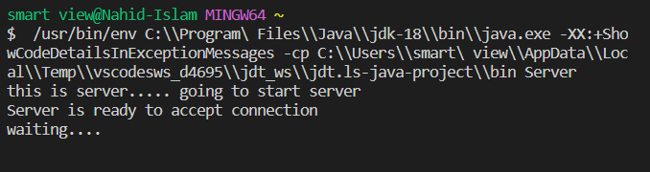

Figure-01

**Sending request to Server:**

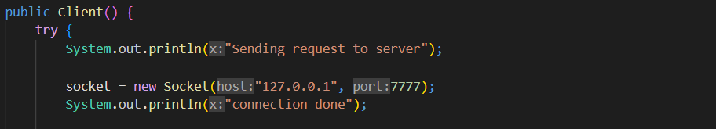

Figure-02

**11**

**Connection done:**

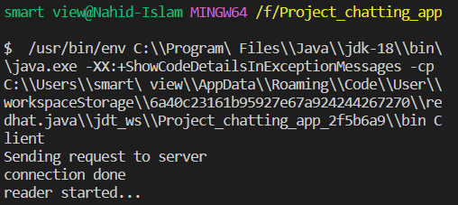

Figure-03

**User Interface:**

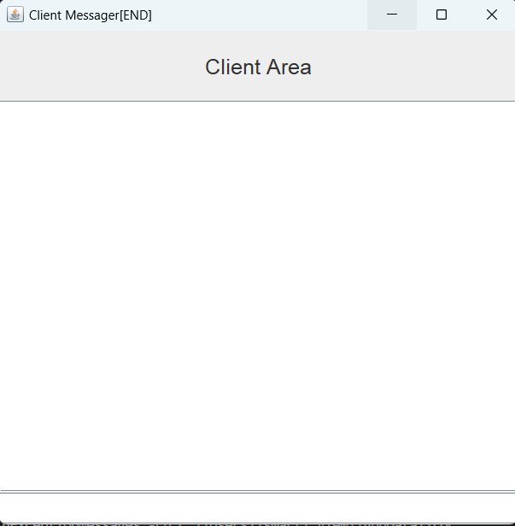

**12**

**After Sending text massage:**

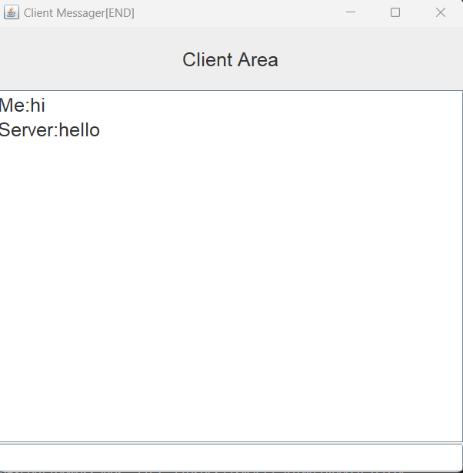

**13**

**After Connection close:**

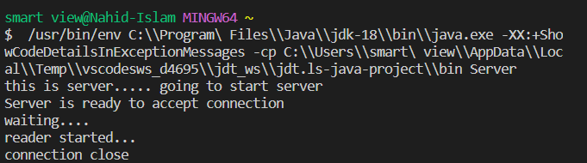

**14**

**Chapter 4**

**Benefit of my Project:**

1. **Real-time Communication:** The chat application allows users to engage in real-time communication, enabling instant message exchange and fostering efficient collaboration.
2. **Scalability:** Java socket programming facilitates the creation of a client-server architecture, allowing multiple clients to connect to a central server. This enables the chat application to scale and accommodate a growing number of users.
3. **Platform Independence:** Java is a platform-independent language, meaning the chat application can be deployed on various operating systems without significant modifications.
4. **Network Efficiency:** Socket programming in Java provides low-level network access, allowing for efficient data transmission and reduced latency.
5. **Flexibility and Customization:** Java socket programming provides developers with flexibility to design and customize the chat application according to specific requirements, adding features or modifying functionality as needed.
6. **Learning Opportunity:** Implementing a chat application with Java socket programming provides an excellent opportunity to gain hands-on experience with network communication concepts, socket programming techniques, and distributed systems.

**15**

1. **Collaboration and Connectivity:** The chat application fosters collaboration among users by providing a platform for easy and seamless communication. It enables connectivity between users in different locations, facilitating effective communication and information sharing.
2. **Potential for Further Development:** Once the basic chat application is developed, it can serve as a foundation for further enhancements and expansions, such as adding security features, incorporating file sharing functionality, or integrating with other systems.
3. **Transferable Skills:** Working on a chat application with Java socket programming enhances skills in Java programming, network communication, and software development, which can be applied to other projects and scenarios.
4. **Practical Application**: Chat applications are widely used in various industries, including business, education, and social networking. Developing a chat application with Java socket programming equips developers with a valuable skill set that can be applied to real-world scenarios.

**16**

**4.2.Future Look**

**Enhanced Security Features:** Implement robust authentication mechanisms to ensure secure communication between clients and the server. Integrate encryption techniques to protect sensitive information and prevent unauthorized access.

**File Sharing Functionality:** Expand the chat application to support file sharing between clients. Enable users to upload and download files directly within the chat interface, facilitating easy collaboration and document exchange.

**Multimedia Support:** Enhance the chat application to handle multimedia content, such as images, videos, and audio files. Enable users to share and view multimedia content within the chat interface.

**Group Chat and Channels:** Implement group chat functionality, allowing users to create and join chat groups. Support public and private channels for specific topics or interest groups, enabling targeted communication and collaboration.

**Mobile Application Development:** Extend the chat application to mobile platforms by developing native mobile applications. This allows users to access the chat application on their smartphones or tablets, increasing convenience and accessibility.

**Performance Optimization and Scalability:** Continuously optimize the chat application's performance, scalability, and resource utilization. Implement load balancing techniques and optimize network protocols to handle increasing user traffic and ensure smooth communication.

**Voice and Video Calling:** Integrate voice and video calling capabilities into the chat application. Enable users to initiate audio and video calls directly from the chat interface, fostering more immersive and interactive communication.

**17**

**4.3.Conclusion**

In conclusion, the Chat Application with Java Socket Programming project has successfully developed a robust and efficient chat application using Java socket programming.

The project has achieved its objectives of enabling real-time communication between multiple clients over a network.

By implementing the client-server model, users can connect to a central server and exchange messages seamlessly.

The application demonstrates the power of socket programming in establishing reliable connections and facilitating efficient message transmission.

Through thorough testing, the application has proven its functionality and reliability in handling various scenarios.

The project has enhanced our understanding of network communication, socket programming concepts, and distributed systems.

Future enhancements such as security features, file sharing, and multimedia support can further enhance the application's functionality.

Overall, the Chat Application with Java Socket Programming project has been a valuable learning experience and has provided a solid foundation for building more advanced communication systems.

**Reference :**

1. https://www.youtube.com/watch?v=6oBePDVZHYc

**18**